**Practical 2 : a) Write a shell script with basic commands like echo and read**

**b) Write a shell script to display addition of given two numbers**

**a)**

echo "enter you name "

read name

echo "hello $ name welcome to shell script"

Output :

enter you name

prince kavar

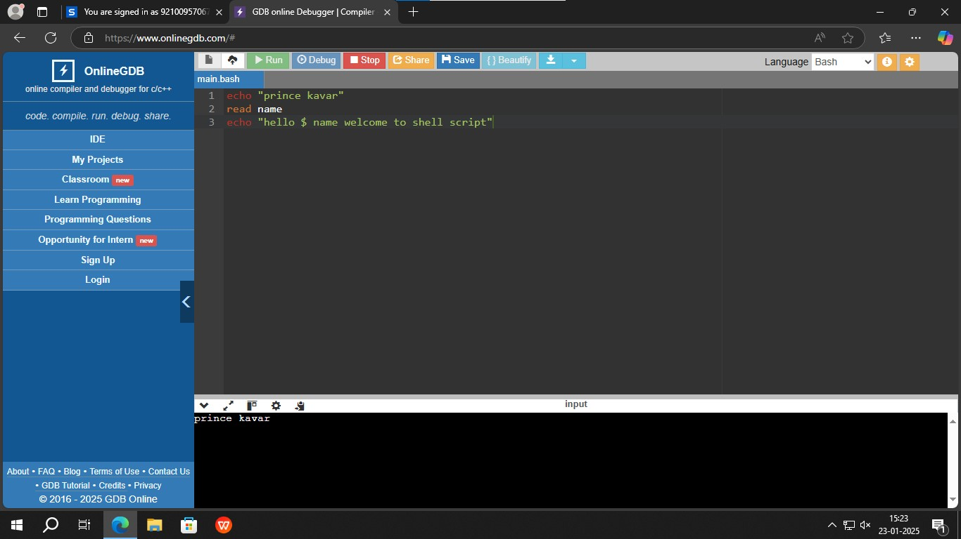

**Figure 2.1 : printing in bash**

b)

echo "my name is Prince Kavar"

echo "my enrollment number is 92410103120"

echo "my class is EC5-C"

echo "enter num1"

read num2

echo "enter num2 "

read num2

sum=$((num1+num2))

echo "sum is $sum"

Output:

my name is Prince Kavar

my enrollment number is 92410103120

my class is EC5-C

enter number 1 :

12

enter number 2 :

12

result: 24

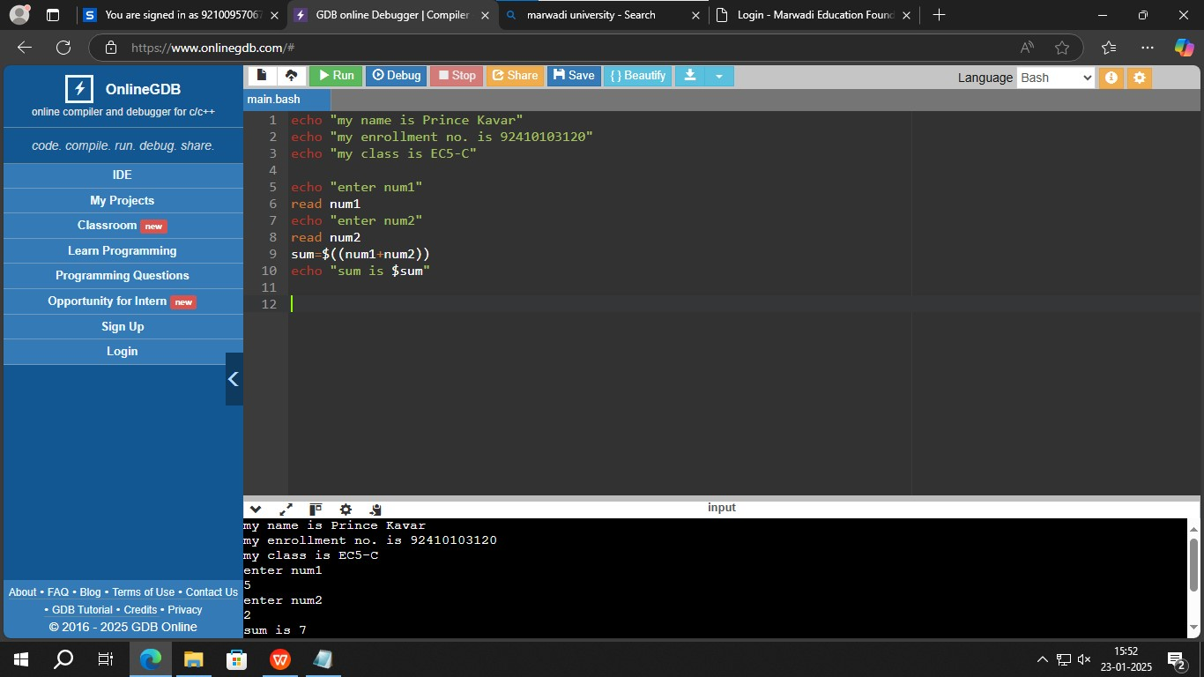

Figure 2.2 : adding two numbers